Software Requirements

Specification

for

ServeU

Version 1.1

Prepared by

MD Faizal - 2000290120095

Manish Kumar Mandavi – 2000290120090

Harsh Choudhary – 2000290120071

KIET Group of Institutions, Ghaziabad

April 2023

**Table of Contents**

1. Introduction ................................................................................................ 3
   1. Purpose .......................................................................................................... 3
   2. Document Conventions .................................................................................. 3
   3. Intended Audience and Reading Suggestions ................................................ 3
   4. Product Scope ................................................................................................ 3
   5. References ...................................................................................................... 3
2. Overall Description .................................................................................... 3
   1. Product Perspective ....................................................................................... 3
   2. Product Functions .......................................................................................... 4
   3. User Classes and Characteristics .................................................................... 4
   4. Operating Environment .................................................................................. 4
   5. Design and Implementation Constraints ........................................................ 4
   6. User Documentation ...................................................................................... 4
   7. Assumptions and Dependencies..................................................................... 4
3. External Interface Requirements ................................................................ 4
   1. User Interfaces ............................................................................................... 4
   2. Hardware Interfaces ....................................................................................... 6
   3. Software Interfaces…….................................................................................... 7
   4. Communications Interfaces………….................................................................. 7
4. System Features……................................................................................... 8
   1. System Feature 1 .............................................................................................8
5. Other Nonfunctional Requirements ....... ………........................................ 9
   1. Performance Requirements............................................................................ 10
   2. Safety Requirements…….................................................................................. 10
   3. Security Requirements……………….................................................................... 11
   4. Software Quality Attributes………….................................................................. 11
   5. Business Rules ................................................................................................ 12
   6. Other Requirements ............................................................................. 13 Appendix A: Glossary............................................................................ 14 Appendix B: Analysis Models .............................................................. 15

Appendix C: To Be Determined List ........................................................... 16

Revision History

|  |  |  |
| --- | --- | --- |
| Name | Date | Version |
| ServeU | 18th February 2023 | 1.0 |
| ServeU | 15th April 2023 | 1.1 |

**1. Introduction**

**1.1 Purpose**

The purpose of this document is to outline the requirements for ServeU, a user-friendly web application designed to streamline the process of discovering, booking, and managing essential services such as maid, laundry, mess/tiffin services, and general daily services. It aims to address the challenges faced by bachelors in efficiently accessing and managing these services, as well as bridging the communication gap between service providers and users.

**1.2 Scope**

ServeU will provide a comprehensive platform for users to:

* Discover and book essential services.
* Communicate with service providers in real-time.
* Manage service requests and feedback.
* Facilitate online transactions for services.

**1.3 Definitions, Acronyms, and Abbreviations**

SRS: Software Requirements Specification

UI: User Interface

**1.4 References**

ServeU Website:

ServeU GitHub Repository:

**2. Overall Description**

**2.1 Product Perspective**

ServeU operates as a standalone web application accessible through modern web browsers. It serves as a platform connecting users with service providers, facilitating communication and transactions.

**2.2 Product Functions**

* User Registration and Authentication
* Service Discovery and Booking
* Real-time Communication
* Service Management
* Online Transactions
* Feedback and Rating System

**2.3 User Classes and Characteristics**

* Users: Individuals seeking essential services, primarily bachelors.
* Service Providers: Individuals or businesses offering essential services.

**2.4 Operating Environment**

ServeU is a web-based application accessible on various devices with internet connectivity. It utilizes responsive design principles to ensure compatibility with desktop and mobile browsers.

**2.5 Design and Implementation Constraints**

ServeU is developed using React for the frontend, Express for the backend, and MongoDB Atlas for the database. It follows a modular design approach for scalability and maintainability.

**3. External Interface Requirements**

**3.1 User Interfaces**

**A. Landing Page**

* **Description**: The landing page serves as the initial interface users encounter when accessing ServeU. Its design aims to capture users' attention and encourage them to explore the platform further.
* **Components**:
  + **Header**: Includes the ServeU logo and navigation menu, providing links to essential sections like service listings, user profiles, and support.
  + **Hero Section**: Features captivating visuals and brief descriptions highlighting the platform's key features and benefits, such as convenience, reliability, and user-friendliness.
  + **Call-to-Action Buttons**: Prominently placed buttons encourage users to sign up for an account or log in to access the platform's services.
  + **Service Categories**: Offers a visually appealing display of popular service categories (e.g., maid, laundry, cooking), allowing users to quickly navigate to their desired section.

**B. Service Listing Page**

* **Description**: The service listing page presents users with a comprehensive list of available service providers based on their search criteria and preferences.
* **Components**:
  + **Search Bar**: Allows users to search for specific services or service providers by entering keywords or selecting predefined categories.
  + **Filter Options**: Provides advanced filtering capabilities, enabling users to refine search results based on parameters such as service type, location, price range, and ratings.
  + **Service Provider Cards**: Each card represents a service provider and displays essential information such as name, location, service offerings, ratings, and reviews.
  + **Booking Button**: Directs users to initiate the booking process for a selected service provider, prompting them to provide necessary details such as date, time, and specific requirements.

**C. Service Provider Profile Page**

* **Description**: The service provider profile page offers users detailed insights into individual service providers, helping them make informed decisions.
* **Components**:
  + **Profile Picture**: Displays an image representing the service provider, fostering familiarity and trust.
  + **Contact Information**: Provides essential contact details such as phone number, email address, and physical location, facilitating direct communication.
  + **Service Offerings**: Presents a comprehensive list of services offered by the provider, accompanied by detailed descriptions, pricing information, and any special offers.
  + **Ratings and Reviews**: Showcases aggregated ratings and reviews from previous users, offering valuable feedback on the provider's performance, reliability, and customer satisfaction.
  + **Chat Interface**: Enables users to engage in real-time communication with the service provider, facilitating inquiries, bookings, and clarifications.

**D. User Dashboard**

* **Description**: The user dashboard serves as a centralized hub for users to manage their account settings, bookings, and interactions with service providers.
* **Components**:
  + **Account Settings**: Allows users to view and update their profile information, including name, contact details, and password.
  + **Booking History**: Displays a chronological record of past and upcoming service bookings, along with relevant details such as service provider, date, time, and status.
  + **Feedback and Ratings**: Provides users with the opportunity to submit feedback and ratings for services they have received, contributing to the platform's reputation and service quality.
  + **Chat Interface**: Facilitates seamless communication with service providers, displaying ongoing conversations and notifications for new messages.

**E. Service Provider Dashboard**

* **Description**: The service provider dashboard equips service providers with tools and features to manage their services, bookings, and interactions with users effectively.
* **Components**:
  + **Service Listings**: Enables providers to view, add, update, or remove their service offerings, ensuring accurate and up-to-date information for users.
  + **Booking Requests**: Presents incoming service requests from users, allowing providers to accept or reject requests based on availability and preferences.
  + **Chat Interface**: Provides a dedicated platform for real-time communication with users, facilitating prompt responses to inquiries, booking confirmations, and service-related discussions.
  + **Feedback and Ratings**: Offers insights into user feedback and ratings, enabling providers to evaluate their performance, address any concerns, and maintain a positive reputation on the platform.

**3.2 Hardware Interfaces**

1. **Server:**
   * The server infrastructure should be robust and scalable to handle the incoming requests from clients.
   * It should be equipped with sufficient processing power, memory, and storage capacity to ensure smooth operation even during peak usage hours.
   * Redundancy measures such as load balancing and failover systems should be in place to ensure high availability and reliability.
   * Security mechanisms like firewalls and intrusion detection systems should be implemented to protect the server from unauthorized access and cyber threats.
2. **Storage:**
   * The storage solution should be capable of handling large volumes of data generated by the application.
   * It should provide high-speed access to data to minimize latency and ensure optimal performance.
   * Data redundancy and backup mechanisms should be implemented to prevent data loss in case of hardware failures or other disasters.
   * Security measures such as encryption and access controls should be in place to protect sensitive data stored on the storage devices.
3. **Network:**
   * The network infrastructure should provide high-speed and reliable connectivity between clients and the server.
   * It should be scalable to accommodate increasing traffic as the user base grows.
   * Quality of Service (QoS) mechanisms should be implemented to prioritize critical traffic and ensure low latency for real-time communication.
   * Security protocols such as VPNs and SSL/TLS encryption should be used to secure data transmitted over the network and protect against eavesdropping and unauthorized access.

**3.3 Software Interfaces**

ServeU integrates with external payment gateways for processing transactions and utilizes HTTP protocols for communication between clients and servers.

**3.4 Communications Interfaces**

ServeU enables real-time communication between users and service providers through a chat interface.

1. **User-Provider Interaction:**
   * Facilitates seamless communication between users and service providers.
   * Allows users to send queries, requests, and messages to service providers.
   * Enables service providers to respond to user queries, accept or reject service requests, and provide assistance.
2. **Real-Time Messaging:**
   * Supports real-time messaging for immediate interaction.
   * Users can instantly communicate their requirements, preferences, and feedback to service providers.
   * Service providers can promptly respond to user inquiries, address concerns, and confirm service requests.
3. **Documentation and History:**
   * Maintains a record of communication history between users and service providers.
   * Allows users and providers to access past conversations, service requests, and interactions for reference and documentation purposes.
4. **Feedback Mechanism:**
   * Integrates a feedback mechanism to gather user ratings, reviews, and opinions on service quality and provider performance.
   * Enables users to provide feedback after service completion, helping to improve service standards and provider reliability.

**4. System Features**

**4.1 User Registration and Authentication**

* **Description:** Users can register for an account by providing necessary information such as name, email, and password. Authentication mechanisms ensure secure access to user accounts.
* **Inputs:** User-provided registration details (name, email, password).
* **Outputs:** Confirmation of successful registration, authentication tokens for logged-in users.
* **Dependencies:** Integration with backend server for user account management.

**4.2 Service Discovery and Booking**

* **Description:** Users can browse and search for available services based on their preferences and location. They can view service provider profiles, compare prices, and book services.
* **Inputs:** User search queries, location data, service preferences.
* **Outputs:** List of available services, service provider profiles, booking confirmations.
* **Dependencies:** Integration with backend server for retrieving service data and handling bookings.

**4.3 Real-time Communication**

* **Description:** Users can communicate with service providers in real-time through a chat interface. This enables quick inquiries, scheduling adjustments, and clarifications.
* **Inputs:** User messages, service provider responses.
* **Outputs**: Real-time chat messages, notifications for new messages.
* **Dependencies**: Integration with backend server for handling chat messages and notifications.

**4.4 Service Management**

* **Description:** Service providers can manage their service offerings, including adding, updating, or deleting services. They can also view and respond to service requests from users.
* **Inputs:** Service provider updates to service listings, responses to service requests.
* **Outputs:** Updated service listings, notifications for new service requests.
* **Dependencies:** Integration with backend server for managing service data and requests.

**4.5 Online Transactions**

* **Description:** Users can make online payments for booked services through secure payment gateways. Upon successful payment, users receive confirmation of the transaction.
* **Inputs:** User payment details, service booking confirmations.
* **Outputs:** Payment confirmation, service booking details.
* **Dependencies:** Integration with external payment gateways for processing transactions securely.

**4.6 Feedback and Rating System**

* **Description:** Users can provide feedback and ratings for services they have received. This helps improve service quality and reliability by providing valuable insights to both users and service providers.
* **Inputs:** User feedback, ratings for service providers.
* **Outputs:** Aggregated service ratings, feedback summaries.
* **Dependencies:** Integration with backend server for collecting and displaying feedback data.

**5. Other Nonfunctional Requirements**

**5.1 Performance Requirements**

* **Response Time:** The system should respond to user actions within a reasonable timeframe (e.g., less than 3 seconds).
* **Scalability:** The system should be able to handle increasing numbers of users and service providers without significant degradation in performance.

**5.2 Safety Requirements**

**Data Encryption:** User data and payment information should be encrypted to ensure confidentiality and prevent unauthorized access.

**Transaction Security:** Online transactions should be conducted securely using industry-standard encryption protocols.

**5.3 Security Requirements**

**User Authentication:** Strong authentication mechanisms should be implemented to verify the identity of users and prevent unauthorized access.

**Data Protection:** Measures should be in place to protect user data from unauthorized access, manipulation, or theft.

**5.4 Software Quality Attributes**

**Reliability:** The system should be reliable and available for use at all times, with minimal downtime for maintenance or updates.

**Usability:** The user interface should be intuitive and easy to navigate, catering to users with varying levels of technical proficiency.

**5.5 Business Rules**

**Service Availability:** Service providers should specify their availability for bookings, and users should be able to view available time slots when booking services.

**Cancellation Policy:** Clear policies should be in place regarding service cancellations, refunds, and rescheduling.

**6. Other Requirements**

**6.1 Integration with External Systems**

**Payment Gateways:** Integration with external payment gateways for processing online transactions securely.

**Location Services:** Integration with location services to provide accurate service recommendations based on user location.

**6.2 Accessibility**

Accessibility Standards: The system should comply with accessibility standards to ensure that users with disabilities can access and use the platform effectively.

**6.3 Internationalization**

Multilingual Support: The system should support multiple languages to cater to users from diverse linguistic backgrounds.

**6.4 User Training and Support**

User Guides: Provide user guides and tutorials to help users navigate the platform and utilize its features effectively.

Customer Support: Offer customer support channels for addressing user queries, issues, and feedback.

**6.5 Continuous Improvement**

Feedback Mechanisms: Implement mechanisms for collecting user feedback and suggestions for improving the platform.

Regular Updates: Release regular updates and enhancements to address user needs and improve system performance.

**Appendix A: Glossary**

1. **ServeU:** The name of the web application designed to streamline the process of discovering, booking, and managing essential services for bachelors.
2. **User:** An individual who utilizes the ServeU platform to access and manage essential services such as maid, laundry, mess/tiffin services, etc.
3. **Service Provider:** An entity or individual offering various services through the ServeU platform, such as maids, cooks/chefs, laundry services, etc.
4. **Responsive Web Design:** A design approach used in ServeU to ensure optimal viewing and interaction across a wide range of devices and screen sizes.
5. **User Dashboard:** The interface provided to users upon login, where they can search for services, manage their bookings, view feedback, and communicate with service providers.
6. **Service Provider Dashboard:** The interface provided to service providers, allowing them to manage service requests, respond to user queries, update service listings, and view user feedback.
7. **Authentication:** The process through which users and service providers verify their identity to gain access to the ServeU platform.
8. **Chat Module:** A feature within ServeU that enables real-time communication between users and service providers, allowing for inquiries, requests, and feedback.
9. **Feedback System:** A mechanism implemented in ServeU for users to rate and review service providers based on their experience, enhancing transparency and reliability.
10. **Notification System:** A system that sends alerts and updates to users and service providers regarding new messages, service requests, and other relevant activities on the platform.
11. **Service Listing Module:** A module within ServeU that displays a list of nearby service providers based on user requirements, including prices, reviews, and contact details.
12. **Database:** The backend storage system used to store user data, service provider information, service listings, chat logs, and other relevant data in ServeU.
13. **React:** A JavaScript library utilized in ServeU for building the frontend interface, enabling the creation of modular and responsive user interfaces.
14. **Express:** A backend framework used in ServeU to create a web server and handle routing, middleware, and other backend functionalities.
15. **MongoDB Atlas:** A cloud-based database service used in ServeU to store and manage data, providing scalability, flexibility, and reliability for the application.

**Appendix B: Analysis Models**

**1) Use Case Diagram:**

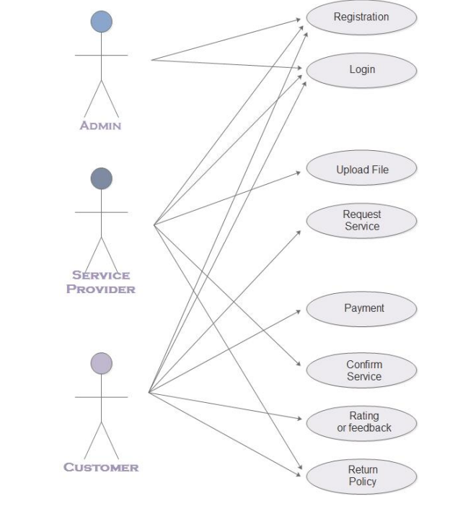

Figure 1: Use Case Diagram

**2) Data Flow Diagram :**

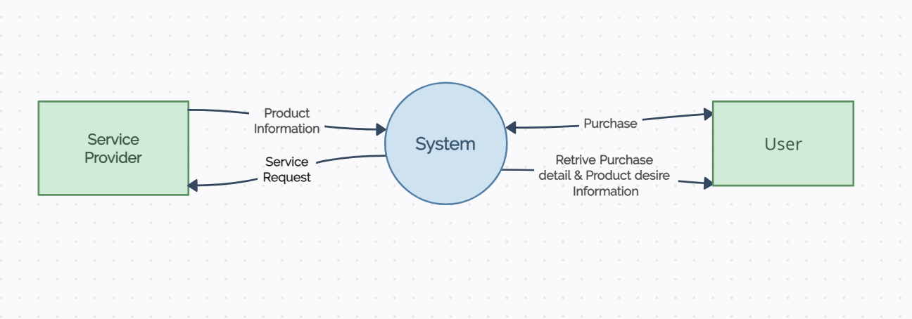

Figure 2: 0-Level DFD

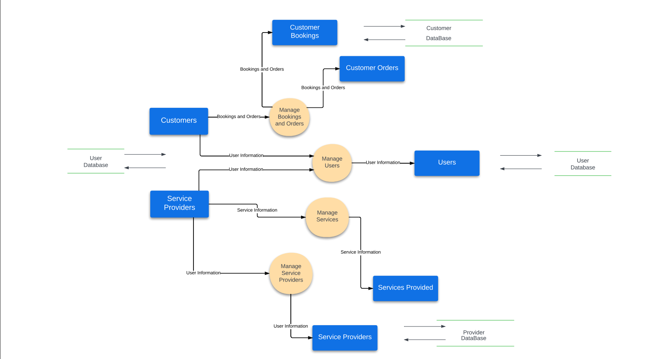

Figure 3: 1-level DFD

**3) ER Diagram :**

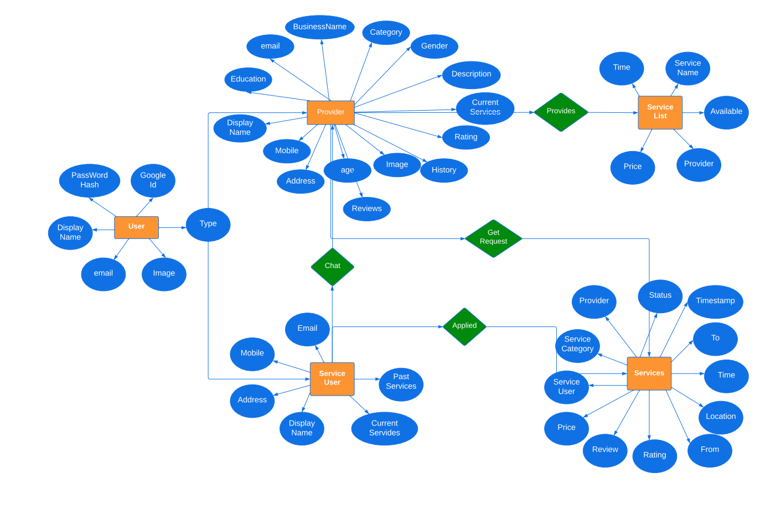

Figure :4 Entity Relation Diagram

**4) Class Diagram**

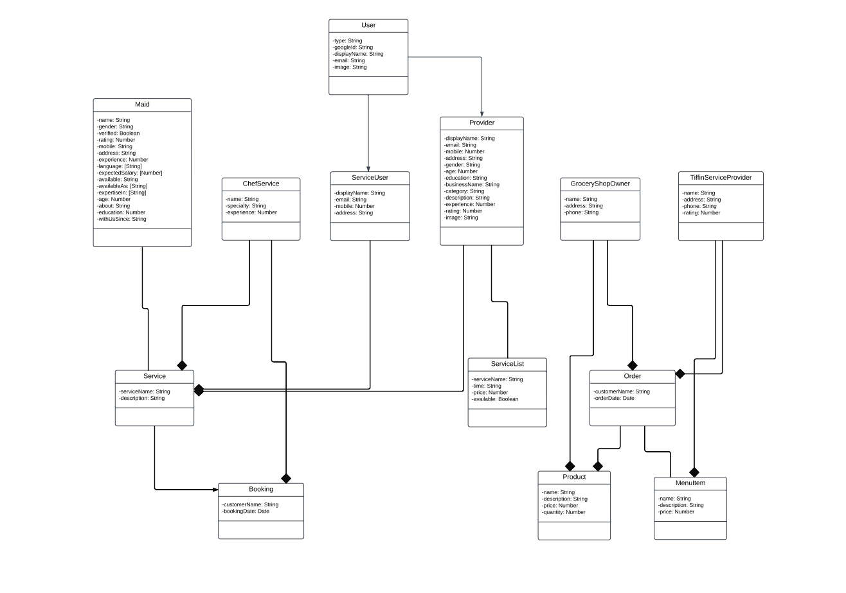

Figure 5: Class Diagram

**5) Architectural Diagram**

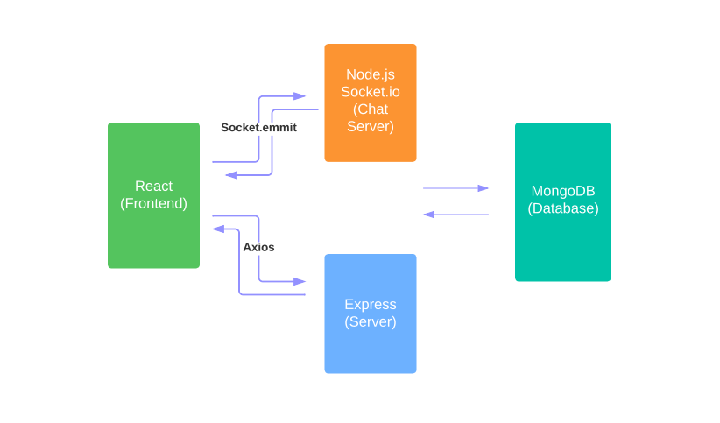

Figure 6: Architecture Diagram

**6) Activity Diagram :**

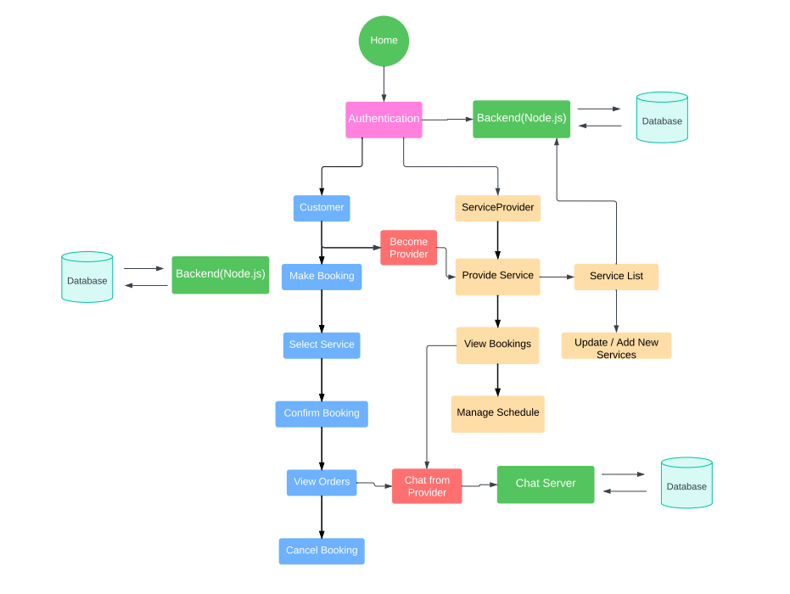

Figure 7: Activity Diagram